INTRODUCTION
The Phú Thượng primary school is situated in Tây Hồ district of central Hanoi; just close to West Lake. The local area has many cafés and charming shops in the neighborhood. You can have relaxing walks with fresh ice-cream on the warmer afternoons.
The school has over one thousand students ranging in age from 6-11 and is a lively and active environment for any volunteer looking to teach. The children do have some knowledge of both English and French, but, as is often the case for Vietnamese students, they have poor pronunciation due to their lack of contact with native speakers even though the school has been received a lot of supports from the government to improve their infrastructure.
There are 40 teachers, of which two are English teachers and two French teachers. English teachers are in charge of 15 classes and are more crowded, with about 40- 50 students per class, meanwhile there are only 2 French classes with 30 students per class
VOLUNTEER’S ROLE
The main task of those volunteering at Phu Thuong is teaching French. The volunteer will provide assistance to the teacher when necessary. This method works very well as, though the Vietnamese teachers speak French well, they need the collaboration from the volunteers to pronounce, to create exercises or games for students. Volunteers have to follow the syllabus stipulated by the governmental program, but can also give helpful feedback and ideas regarding the syllabus.
Volunteers can often introduce fun new learning games which are thoroughly enjoyed by the kids. The children at Phu Thuong School are by now not really used to foreign visitors, so they thoroughly enjoy having the volunteers around. Due to their warm reception, volunteers generally become equally fond of the children and enjoy the program very much.

WORKING TIME
The class duration is 45 minutes and there is a break between classes varying from five to 15 minutes. The volunteer participates in different classes per day, working from Monday to Friday, from 8:25 to 17:00. Saturday and Sunday are off.
The lunch break is from 11:05 to 13:45. There is one break in the morning between 9:10 and 9:30 and one in the afternoon between 15:05 and 15:30
LUNCH
There are several options for lunch.
Volunteers can eat lunch at school if they wish. In this case, volunteers need to inform the school in advance to prepare food for them.
If prefer, volunteers can eat at some street restaurants nearby the school. In this case, volunteers get support of 30.000VND for lunch. They will pay in advance and get the reimbursement on a weekly basis.
Here are some common dishes with prices:
+Noodles (any kinds): 25.000-30.000 dong/bowl.
+Rice: 25.000-30.000 dong/dish.
(Give the money to the seller and point at the food that you want, the seller will pick them into your dish until it reaches the limit of your money)
+Bread: 15.000-30.000 dong/bread (Depend on how big it is).
An email is required to send to admin@vpv.vn stating number of lunch and respective date. VPV admin will check and reimburse money (30,000VND*number of lunch) to volunteers on an agreed date/time.

TRAVEL TO PROJECT
Volunteers normally take the bus number 14 and 58 to the project, which costs 7,000 VND per ride. Volunteers need to collect the bus tickets and give to VPV admin to get reimbursement (same procedure with lunch refund). Those who stay more than two weeks should provide a picture to VPV to make a bus pass. With the bus pass, volunteers just need to show it to the ticket inspector on the bus.
CONTACT:
*At Phu Thuong:
The mentor in Phu Thuong is Mrs. Huong.
The mentor is the person who will be in charge of the volunteer in the placement. Contact her to:
- Inform when you are sick or late, if it is possible one day in advance because they need to know to make the work schedule.
- Information about organizational issues: logistics, timetable, meals, sleeping room after lunch, work material, etc.
- Help related with problems at work. Usually the mentor is the person in the center. As she can speak little English she will be useful and try her best to be a translator between the local staff and the international volunteer.
Contact of Phu Thuong:
Address: No. 143, Phu Gia Str. An Duong Vuong, Phu Thuong Commune, Tay Ho District, Ha Noi.
Phone: 094 501 03 09
*At VPV: The coordinator responsible in VPV head office is Mai.
Address: No.56, lane 99, Nguyen Phong Sac Street, Cau Giay, Hanoi, Vietnam
Phone: 0129 222 7515
Mail : individual@vpv.vn
CHALLENGES AND RECOMMENDATIONS
The volunteer can ask to observe the teachers’ lessons during the first two weeks. We kindly recommend doing this short training to understand the dynamic of Vietnamese classes and to learn some tricks from the local teachers in big size Vietnamese classes.
Teachers have some specific program to teach and sometimes they do not have enough time to finish it on time, which is the reason why the speaking and pronunciation part of the class is reduced in order to have more time for the book exercises. It is common to use the speaking part of the class to correct pronunciation problems instead of giving the volunteers the opportunity to prepare games by themselves. Be patient and proactive; even if you can not prepare activities every day do not lose motivation to propose new games or activities for the class. Remember that your support to the local teacher is also really important for the development of the children’s French skills.
Prepare games to practice pronunciation and speaking skills related to the French program, it will be easier to apply in the class and the children will understand the vocabulary or grammar better. Use funny games or songs but remember that the French level in general is not high so try to prepare activities without complicated instructions or rules and with vocabulary and grammar according to their level. It is useful as well to bring material about your personal life, your country or your hobbies to make them more interested in the class.
Try to be active when you are assisting the French teacher. Some previous volunteers recommended not to stand in front of the class because the children might be embarrassed or they could pay less attention to the teacher. It could be better to walk around the class to help the students with the exercises, correcting them when necessary, helping the teacher to keep them quiet and sit or wait in the back of the class when the teacher is explaining something.
If you want to photocopy material bring it at least one day in advance and show it to the teacher. They will help you with printing it. Be aware that the school has a limited budget so be sensitive to this.
During the journey the volunteer joins different classes. It is possible that he/she will repeat the same lessons several times per day. This is the normal way of working in schools, in Vietnam and in western countries as well.
The volunteers have a detailed schedule about the classes they should join every day. Although, sometimes there can are changes in the schedule, them teachers will usually try to inform you the previous day.
Moreover, there are many classrooms in the whole school so it could be confusing arriving there. It is useful, instead of going directly to the next class, to go to the staff’s room and wait there. The teachers will help you decide which class is best to join and you can follow them to the classroom.
Working in another country always is challenging because of the cultural and organizational differences. You will probably find even other challenges that we did not describe; you have to/will discover them by yourself. Try to be as positive, patient and creative as possible in order to solve it. Do not doubt to ask your coordinator for any help you need, we are here to support you.
As a volunteer you can be really meaningful in helping the children improving their speaking skills and motivate the teachers to learn a more participative and funny way of teaching. Enjoy your volunteer experience!
DOS AND DON’TS
- Dress more conservatively when teaching at the school. It is not considered appropriate showing knees or shoulders.
- Contact your coordinator from VPV if there is any misunderstood between you and the teachers. Or if you need any advice to communicate with the staff and teachers from school effectively and friendly.
- Do not smoke in the school, even in the garden or open-air areas. It is a bad model for the children or adolescents. Neither give nor accept cigarettes from teenager students. If you are a smoker please leave the school area to smoke.
- Do not lose your temper in public. Even if you are frustrated or feel you are being mistreated, to show anger will be seen as a serious loss of face and will rarely help you achieve what you want. It is more effective to smile, show patience and ask again about what you need.
- Do not correct the French teacher in front of other teachers or students. You should avoid hurting the others feelings. During your speaking and pronunciation exercises you will have the chance to correct all the mistakes you feel necessary to correct.
BASIC TIPS
- Speak slowly, repeat often
- Write things you are saying on the board if you notice that the children are not understanding you
- Walk through the class during class, explain the task again to single students, make them work and take away Math books, comics, letters...
- Create as many different games related to the topic as possible. The students love games/ activities
- Explain the task from the book in your own, more simple words
- The students are competitive. Divide the class in two or use rows. They love teams.
- Don’t let them use their solution books (or you’ll have exactly the same dialogue and same opinions from all students).
- Don’t let them do what they are not supposed to do with the other teachers. You might want to be their friend but then you’ll lose their respect as a teacher.
- They are intelligent students. Keep varying lessons but do not overdo the games( Hangman can be used to introduce a topic)
- Use the ESL web sites to find materials and word search maker sites to give relevant word searches
- Do not put up with mobile phones, talking over other students
- Do not put up with bad behavior. The school teachers will deal with it if you ask for their help.

PHOTO GALLERY

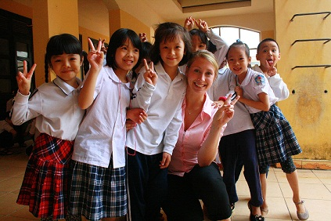  Students and volunteer | 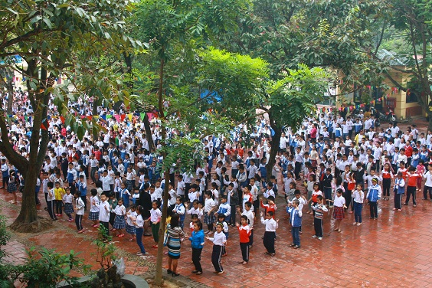  School in flag salutation  S

